Stride WMS
Client Inventory & Transfers Guide
Version 2.6.0 | March 2026
For Warehouse Admin Staff

Table of Contents
(This page will auto-update when opened in Word. Right-click > Update Field.)

1. Overview
The Client Inventory spreadsheet is the central hub for managing a single client’s warehouse operations. Each client has their own Google Spreadsheet containing tabs for receiving, inventory tracking, tasks, repairs, shipments, and billing.
Key tabs: Dock Intake, Inventory, Tasks, Repairs, Shipments, Billing_Ledger, Settings
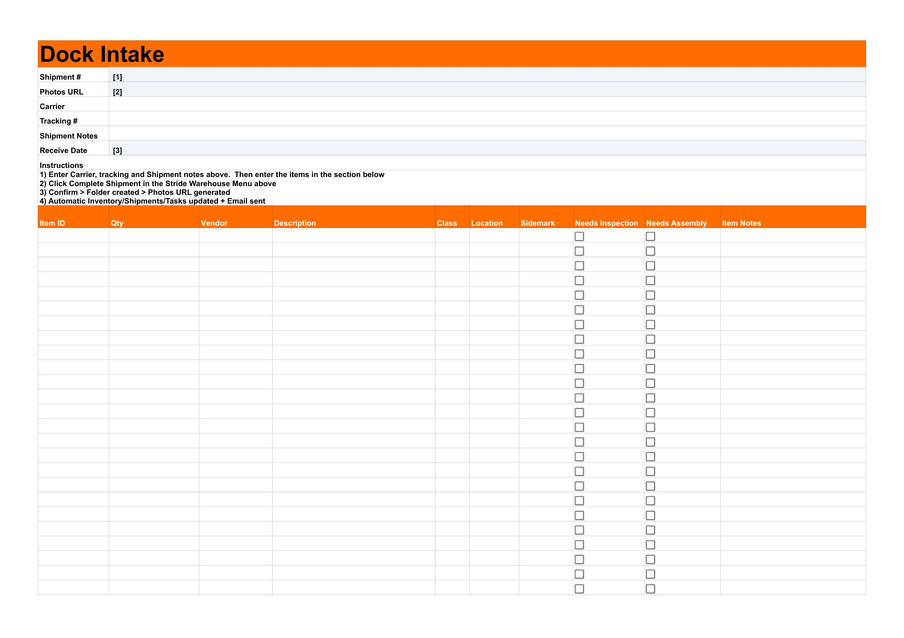

2. Dock Intake — Receiving New Shipments

2.1 Opening the Dock Intake Tab
- Open the client’s inventory spreadsheet
- Click the “Dock Intake” tab at the bottom


2.2 Filling In Shipment Information
Fill in the form fields at the top of the sheet:
Field | Description
Shipment # | Auto-filled. Do not edit.
Photos URL | Auto-filled after completion.
Carrier | Shipping carrier name (FedEx, UPS, etc.)
Tracking # | Carrier tracking number
Shipment Notes | Any notes about the delivery
Receive Date | Leave blank to use today’s date, or enter a specific date


2.3 Adding Items to the Grid
Starting at row 11, enter each item:
Column | Required? | Description
Item ID | Yes | Unique identifier for the item
Qty | Yes | Number of pieces
Vendor | No | Manufacturer or vendor name
Description | Yes | What the item is
Class | Yes | Size class (XS, S, M, L, XL, XXL) — dropdown
Location | No | Warehouse location/bay
Sidemark | No | Project name or job reference
Needs Inspection | No | Check if item needs inspection
Needs Assembly | No | Check if item needs assembly
Item Notes | No | Additional notes


2.4 Completing the Shipment
- Review all items in the grid
- Click Stride Warehouse menu at the top
- Click “Complete Shipment”
- Confirm the dialog

What happens automatically:
- A Google Drive folder is created for the shipment
- Photos URL is generated and filled in
- Items are added to the Inventory tab
- A Shipment record is created in Shipments tab
- If Auto Inspection is ON, inspection tasks are created
- If Enable Receiving Billing is ON, RCVG billing rows are created
- If Enable Shipment Email is ON, a confirmation email is sent
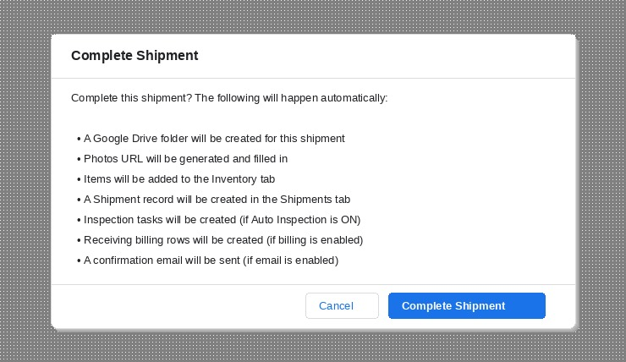

3. Inventory Tab

3.1 Understanding the Columns
Column | Description
Item ID | Unique item identifier
Qty | Number of pieces
Vendor | Manufacturer
Description | Item description
Class | Size class (affects storage billing rate)
Location | Current warehouse location
Sidemark | Project/job reference
Room | Room designation
Photos URL | Link to item photos folder
Status | Active, Released, or Transferred
Receive Date | When the item arrived
Release Date | When the item was released (if applicable)

3.2 Item Status Values
Status | Meaning
Active | Item is currently in the warehouse
Released | Item has been released/shipped out
Transferred | Item was moved to another client account

3.3 Creating Tasks from Inventory
- Find the item row in the Inventory tab
- Select a Task Type from the dropdown (e.g., Inspection, Assembly)
- Check the “Create Task” checkbox
- A new task row is automatically created in the Tasks tab
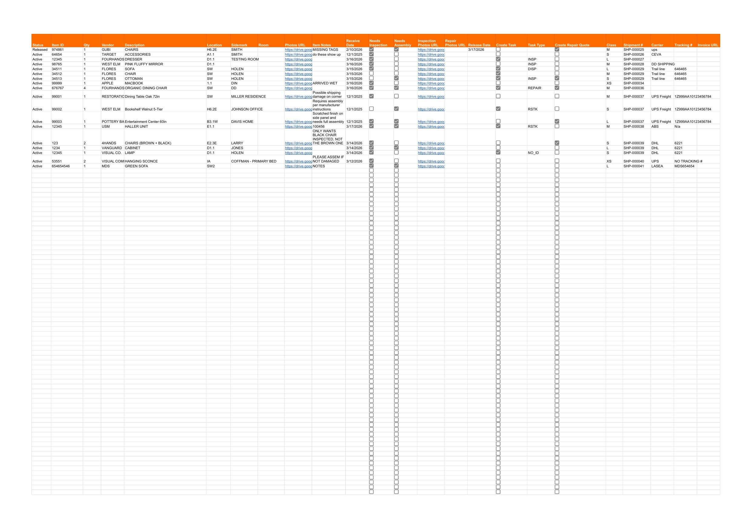

3.4 Creating Repair Quotes from Inventory
- Find the item row
- Check the “Create Repair Quote” checkbox
- A new repair row is created in the Repairs tab with status “Pending Quote”


4. Tasks Tab

4.1 Understanding Task Columns
Column | Description
Source Task ID | Unique task identifier
Item ID | Which inventory item this task is for
Svc Code | Service code (INSP, ASSY, etc.)
Status | Open, Completed, or Cancelled
Result | Pass or Fail (green/red color)
Task Notes | Notes about the task
Billed | Checkbox — checked when billing row has been created
Completed Date | Auto-filled when result is entered

4.2 Task Workflow
- Task is created (Status = “Open”)
- Warehouse staff performs the work
- Staff enters a Result: Pass or Fail
- Status automatically changes to “Completed”
- Completed Date is auto-filled
- A billing row is created in Billing_Ledger (if billable)
- Billed checkbox is checked

4.3 Result Formatting
- Pass = Green background with white text
- Fail = Red background with white text
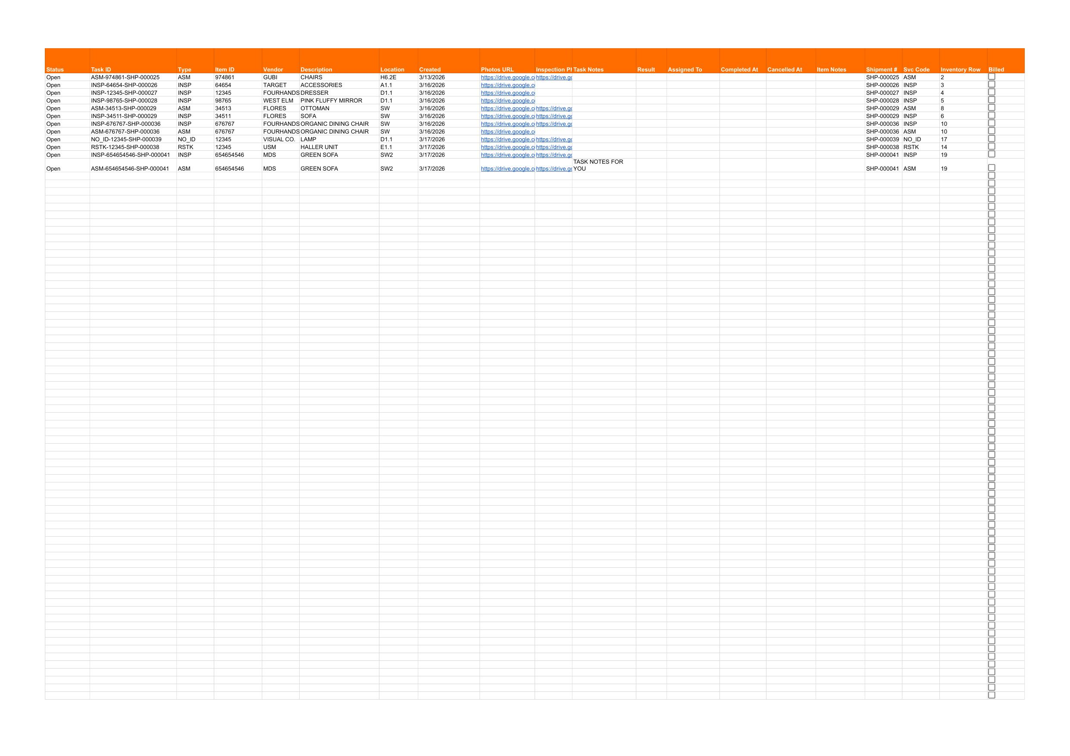

5. Repairs Tab

5.1 Understanding Repair Columns
Column | Description
Item ID | Which inventory item
Status | Current repair status
Quote Amount | Dollar amount for the repair quote
Approved | Checkbox — client approves the quote
Repair Result | Pass or Fail
Repair Vendor | External vendor (if applicable)
Repair Notes | Notes about the repair

5.2 Repair Workflow
The repair process follows this sequence:
- Pending Quote — Repair quote request created
- Quote Sent — Quote amount entered, email sent to client
- Approved — Client checks Approved checkbox
- In Progress — Work begins (or Declined if client declines)
- Complete — Repair finished, result entered

Status | Triggered By
Pending Quote | Create Repair Quote checkbox on Inventory
Quote Sent | Entering a Quote Amount
Approved | Checking the Approved checkbox
Declined | Admin manually sets status
In Progress | Admin manually sets status
Complete | Entering a Repair Result (Pass/Fail)

5.3 Quote Emails
When a Quote Amount is entered, the system automatically:
- Changes status to “Quote Sent”
- Records the Quote Sent Date
- Sends an email to the client with the quote details (if notifications are enabled)

5.4 Approval
When the Approved checkbox is checked:
- Status changes to “Approved”
- An approval confirmation email is sent to staff
- Inspection photos are linked if available
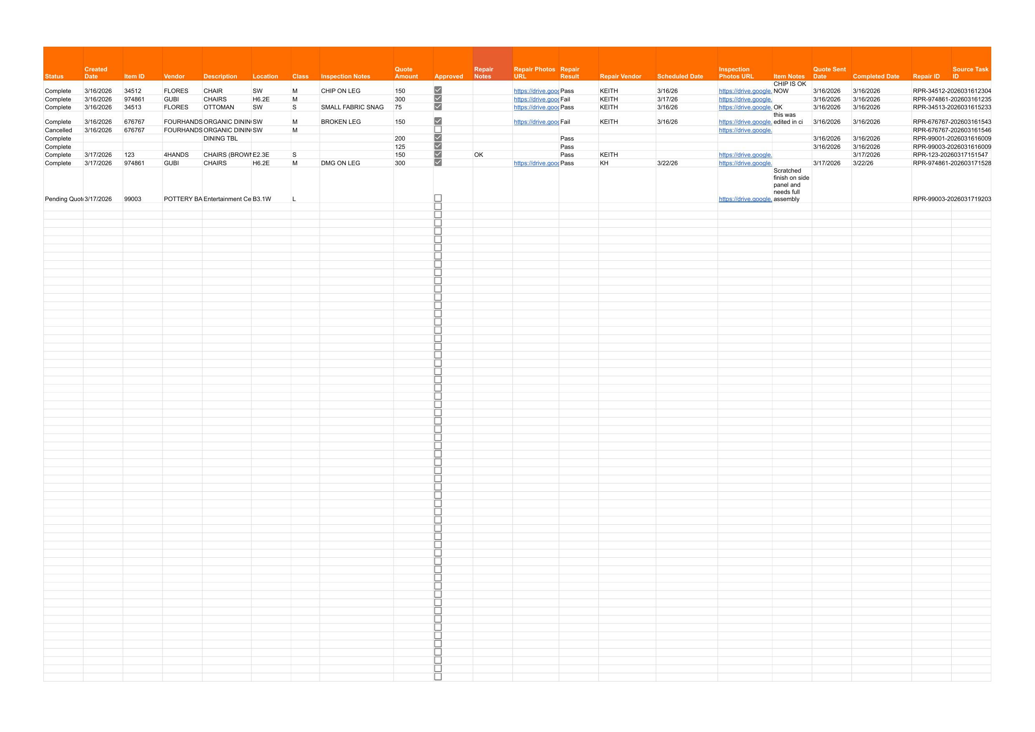

6. Shipments Tab
The Shipments tab is a read-only log of all shipments received.
Column | Description
Shipment # | Unique shipment identifier
Receive Date | When the shipment arrived
Item Count | Number of items in the shipment
Carrier | Shipping carrier
Tracking # | Tracking number
Photos URL | Link to shipment photos folder
Shipment Notes | Notes about the shipment
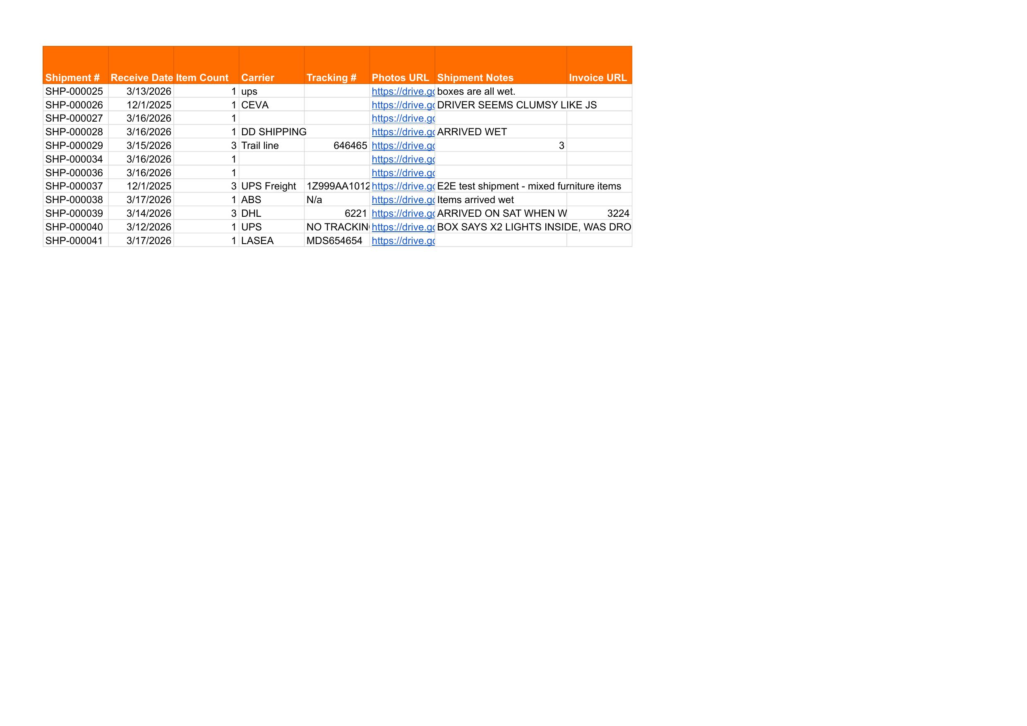

7. Billing Ledger Tab

7.1 How Billing Rows Are Created
Billing rows are created automatically by the system:
- RCVG (Receiving): Created when Dock Intake is completed (if enabled)
- INSP / Custom Tasks: Created when a task is completed
- REPAIR: Created when a repair is completed
- STOR (Storage): Created by the monthly storage charge generation

7.2 Billing Status Values
Status | Meaning
Unbilled | Charge has not been invoiced yet
Invoiced | Charge has been included in an invoice
Voided - Transferred | Charge was voided because the item was transferred

7.3 Ledger Entry ID
Each billing row has a unique Ledger Entry ID (e.g., BL-000001). This ID:
- Links the billing row to invoice records
- Prevents duplicate charges
- Enables the transfer system to move charges between clients

Important: Do NOT manually edit Ledger Entry IDs.
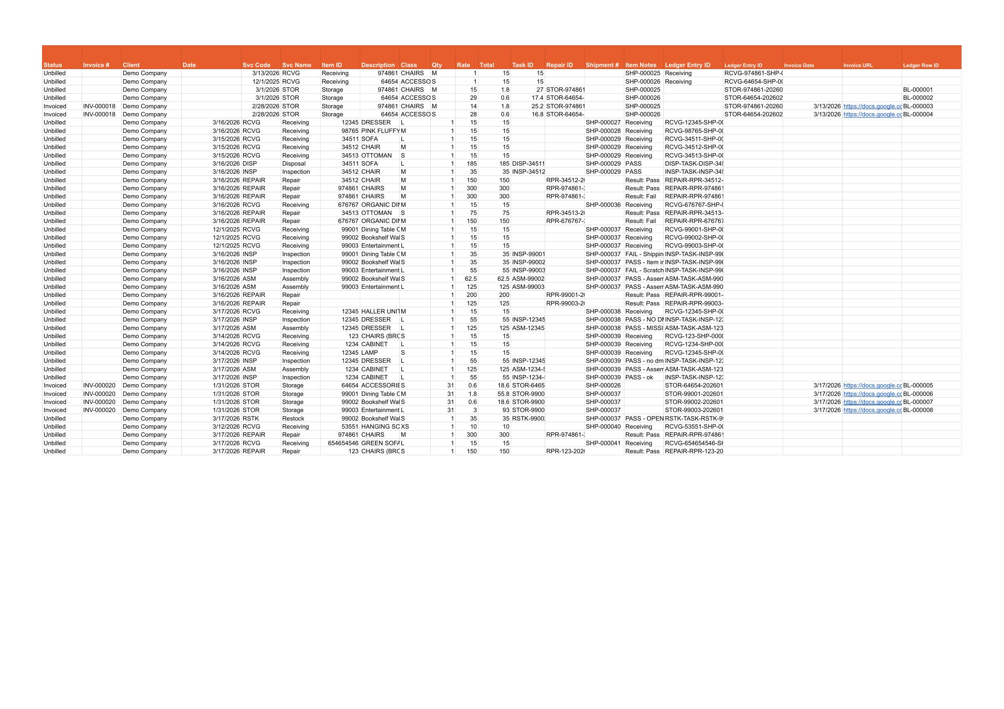

8. Transfer Items

8.1 When to Use Transfers
Use the Transfer Items function when:
- An item was received under the wrong client account
- Items arrived with no customer info and were logged to a holding account
- A client’s items need to be reassigned to a different account

8.2 Step-by-Step Transfer Process
- Open the SOURCE client’s inventory spreadsheet
- Click on the Inventory tab
- Select the rows you want to transfer (click row numbers to highlight multiple rows)
- Click Stride Admin → Transfer Items...
- The Transfer dialog opens showing the selected items
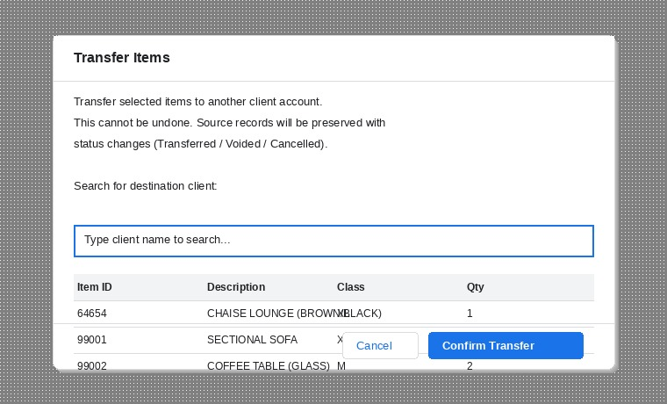
- Use the search box to find the destination client
- Select the destination client from the dropdown
- Review the items listed in the preview table
- Click “Confirm Transfer”
- Wait for the transfer to complete (do not close the window)

8.3 What Gets Transferred
Data | What Happens on Source | What Happens on Destination
Inventory rows | Status → “Transferred” | Items copied with all details
Unbilled billing rows | Status → “Voided - Transferred” | New Unbilled rows created
Active tasks | Status → “Cancelled” | Tasks copied as active
Active repairs | Status → “Cancelled” | Repairs copied as active
Photo folders | Unchanged | Folders copied to destination Drive

8.4 What Does NOT Transfer
- Already invoiced billing rows (these stay on the source)
- Completed or cancelled tasks
- Completed or cancelled repairs

8.5 Audit Trail
Nothing is deleted during a transfer. Every source record is preserved with:
- A status change (Transferred, Voided, or Cancelled)
- A note with the transfer timestamp and destination client name

This ensures you always have a complete history of where items came from.

9. Settings Tab
The Settings tab contains configuration for this client. It uses a Key/Value format.
Important: Some values are auto-filled during onboarding. Do not edit auto-filled values unless instructed.
Key | Description | Auto-Filled?
CLIENT_NAME | Client display name | Yes (from onboarding)
CLIENT_EMAIL | Client contact email | Yes
FREE_STORAGE_DAYS | Days before storage charges begin (e.g., 30) | Yes
PAYMENT_TERMS | Payment terms for invoices | Yes
DISCOUNT_STORAGE_PCT | Storage discount percentage (0-100) | Yes
DISCOUNT_SERVICES_PCT | Services discount percentage (0-100) | Yes
SEPARATE_BY_SIDEMARK | TRUE/FALSE — separate invoices by sidemark | Yes
ENABLE_RECEIVING_BILLING | TRUE/FALSE — auto-bill receiving | Yes
ENABLE_SHIPMENT_EMAIL | TRUE/FALSE — send email on shipment | Yes
ENABLE_NOTIFICATIONS | TRUE/FALSE — master notification toggle | Yes
AUTO_INSPECTION | TRUE/FALSE — auto-create inspection tasks | Yes
QB_CUSTOMER_NAME | QuickBooks customer name (if different) | Yes
MASTER_SPREADSHEET_ID | Master Price List sheet ID | Yes
DRIVE_PARENT_FOLDER_ID | Client’s Drive folder ID | Yes
MASTER_RPC_URL | Server endpoint URL | Yes
MASTER_RPC_TOKEN | Server authentication token | Yes
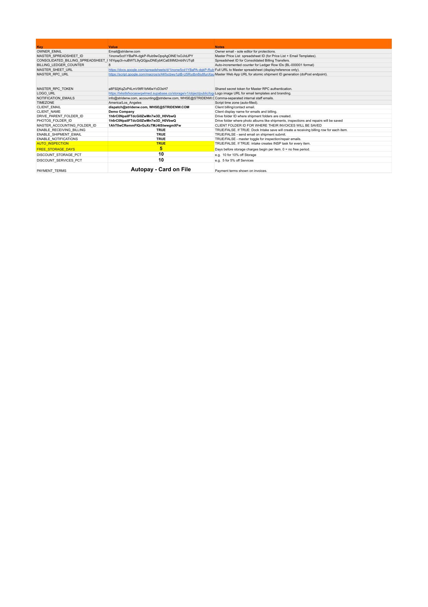

10. Stride Admin Menu
Access via: Stride Admin menu at the top of the spreadsheet.
Menu Item | What It Does
Update Headers & Validations | Safely adds any missing columns, fixes dropdowns and checkboxes. Run this after script updates.
Install Triggers | Sets up automatic edit triggers. Run once after setup.
Refresh Price/Class Cache | Pulls latest pricing and class data from the Master Price List.
Transfer Items... | Opens the transfer dialog (select Inventory rows first).

Tip: If you see unexpected behavior after a script update, run “Update Headers & Validations” first. This fixes most issues without affecting your data.
